# connecting jenkins with kubernetes cluster

Install Kubernetes Continuous Deploy Plugin, once its installed successfully. goto manage jenkins --> manage credentials --> Click on jenkins global --> add credentials

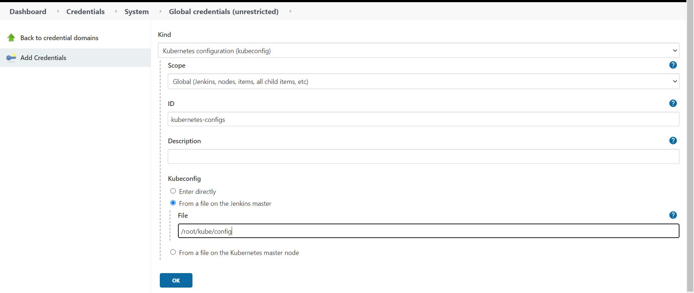

select

**->Kind:** Kubernetes Configuration

**->Scope:** Global

-> **ID:** kubernetes-configs ( any meaningful name )

**->Kubeconfig :** copy the content of kubernetes config file and place it at the file **/root/kube/config** in jenkins host

And click **OK**

and in Jenkinsfile you refer as mentioned below

stage('connecting to k8s cluster'){

steps{

script{

withCredentials([kubeconfigFile(credentialsId: 'kubernetes-config', variable: 'KUBECONFIG')]) {

dir ("kubernetes/"){

sh 'helm list'

sh 'helm upgrade --install --set image.repository="nexus_ip:8083/springapp" --set image.tag="${VERSION}" myjavaapp myapp/ '

}

}

}

}

}